**ECE3502 – IoT Domain Analyst**

**Project Report**

**IoT based system for monitoring Heart Health and predicting Heart diseases.**

*By*

*18BCE1241 Mihir Suman*

*18BCE1267 Alpanshu Kataria*

*18BCE1097 Mehul Malik*

B.Tech. Computer Science and Engineering

*Submitted to*

Prof.Maheshwari R

**School of Computer Science and Engineering**



*June 2021*

**Abstract**

The recent advances in Internet of Medical Things(IoMT) allows developing of moderate to low cost health tracking wearables.These sensors converts various human vital parameters into electrical signal/impulses.This report presents a way for the doctor’s to queue the patients according to their present heart health condition.They are prioritized in order as High Risk/Low risk by feeding the essential’s of the patient and training the model through random forest and the dataset entry as .csv File was made created with the help of Node-Red,it also enabled to take sensor values mainly rest bps,cholesterol,blood sugal level etc as they could not be filled by the patient in patient doctor interaction form.The obtained result has shown real time classification of risk and had provided a way of analyzing the health dataset inputted parameters more accurately by feeding them into the cloud(Microsoft Azure) thereby visualizing them and therefore providing doctor with more detailed condition of the patient.

**Requirement of this project to the society** is that it will help in replacing the manual patient monitoring in the ICU which in turn will mean more beds and resources available for other, more critical patients.

Our project can be beneficial to the society ,as nowadays more and more people are getting affected with heart related diseases such as Atrial fibrillation and ventricular tachycardia which is breath disorder. Based on the input of sensors and input from person we can detect if the person is suffering or not. This will be done by training the machine learning classification model on existing dataset and based on the input from sensors and user.

**Introduction**

Today as we see around the world except few countries most of the country's health infrastructure is very poor. Today where countries like USA Japan and Germany spend more than 10% of the GDP on health, India spends only 2.5 % to 3 % of the GDP on health infact there are very few nurses and doctors available per thousand in our country. If we want to improve the situation we shall definitely make use of technology to our advantage. Keeping that goal in mind we have decided to make an application which will help to handle more patient in less time. The application can be used to prioritize the patients according to the category of High risk/low risk.So that the patient who need to be immediately handled by expert Doctor’s panel can avail the service in time.We have seen the situation in current pandemic scenario where a lot of people get admitted into the hospital but only few require serious attention but since doctors are unable to prioritize the patients many people lost their lives.

We have designed the solution on heart Disease dataset and by changing training dataset the application can be utilized in many different types of diseases.

* **Motivation**
* IoT based system for monitoring Heart Health can help doctors prioritize patients, and provide urgent care to those who are in the most danger thereby saving lives.
* Proper integration and incorporation of IoT elements can help utilize the resources of the hospital more wisely and save money.
* It is convenient to use the system for patients and also medical experts.
* The devised idea is convenient and portable so it is very convenient for doctors to manage patients from one web UI filled form.
* **Challenges**
* **Data Security:** The data is transmitted from the sensors to the users systems and then accordingly communicated to them through email or messages. Now in between these transmissions there is a possibility that some hacker can trespass the system and gain access to the patient's valuable health information.
* **Cost of Sensors:** The system has sensors involved in it which are a bit costly but to get accurate health information one has to use the best sensors. So it might become difficult for some people to afford it.
* **System Integrations:** Since there are hardware and software components involved in the system the integrations between them might become a bit complex and everyone might not be able to do that. So one needs a trained person to handle a such idea.Although we aspired to make a hardware related integration into our project but due to the pandemic we were unable to get and work upon hardware part.
* **Real-time Access to Data:** The Smart heart health Monitoring system in order to give the best, most precise and accurate result needs real time access to the patients data and so it might become challenging to provide uninterrupted internet connection in village areas.

**Literature Survey/Related Works**

**Surveys**

|  |  |
| --- | --- |
| **Sl. No.** | 1 |
| **Title of the paper** | Development of Smart Healthcare Monitoring System in IoT Environment[1] |
| **Journal or conference** | SpringerLink  Published: 26 May 2020 |
| **Dataset used** | Value of different sensors (Heart Beat, Body temperature sensors) in different conditions |
| **Methodology** | The system is implemented using the combination of hardware components. Here the value accessors are connected with ESP32 using physical pins. For all value accessors, the *V*cc and GND are connected with the *V*cc and GND pin of ESP32. Heart beat measuring sensor, the signal pin is connected with D26 pin of ESP32. |

|  |  |
| --- | --- |
| **Conclusion** | The system introduced smart healthcare to monitor the basic important signs of patients like heart rate, body temperature, and some measures of hospital room’s condition such as room humidity, the level of CO and CO2 gases. The rate of success between the observed data and actual data is approximately greater than 95% for all cases of the developed healthcare system. Registered medical staff can view and trace the data in real-time even if the patients do the tests outside of the hospital. |
| **Future scope** | The system looks somewhat bulky, it can be made a tiny device by proper manufacturing in the near future. The video feature can be integrated for better communication between the doctors and patients.There are some more considerable amount of measures which are very significant to determine a patient’s condition like the level of diabetes, respiration monitoring, etc. can be addressed as future work. |

|  |  |
| --- | --- |
| **Sl. No.** | 2 |
| **Title of the paper** | Continuous heart rate and body temperature monitoring system using Arduino UNO and Android device[2] |
| **Journal or conference** | December 2015 2nd International Conference on Electrical Information and Communication Technologies (EICT) |
| **Dataset used** | Heart Rate and Body Temperature datasets |
| **Methodology** | They have constructed an efficient and affordable device for measuring heart rate and temperature, an infrared Tx and Rx have been used to measure the pulse by measuring the variation in blood flow regulation through anyone of the fingers. A noise filter has been designed to filter out any unwanted noise and interference, due to small movement of finger causes excess noise. |

|  |  |
| --- | --- |
|  | A temperature sensor has been used to measure body temperature. The microcontroller of the Arduino UNO board is programmed to count the pulse rate and to measure the body temperature and to send the information to the developed “Heartmate” android application via Bluetooth module |
| **Conclusion** | In this paper, they have shown a design of a heart rate and body temperature measuring embedded system. The final outcome of our approach is an android based portable heart rate and body temperature measurement system with a suitable architecture which can be applicable in medical and home appliances in patient health monitoring system. |
| **Future scope** | The device can be enhanced to be used with iOS applications as presently it is working only on Android and not only this it can also be made to work on a video conferencing mode to have interaction with the doctors as well. |

|  |  |
| --- | --- |
| **Sl. No.** | 3 |
| **Title of the paper** | Design of a contactless body temperature measurement system using Arduino[3] |
| **Journal or conference** | September 2020 Indonesian Journal of Electrical Engineering and Computer Science 19(3):1251 |
| **Dataset used** | The datasets of various diseases like fever, hypothermia, hyperthermia was used to get train the model. |
| **Methodology** | The proposed system starts with initialization of temperature sensors for collection of real time temperature data in compare to environmental temperature values. The sensitivity of temperature sensors LM35 (S1) and MLX-90614 (S2) is programmed in C++ language and access through Arduino CT-UNO controller. The ports of configured WIFI shield are powered from 5V internal supply of CT-UNO controller to transmit the collected data at online portal. This system is designed without push button scheme to attain the wireless monitoring of  temperature. |
| **Conclusion** | Most of the Healthcare organizations need a real-time,stagnant and accurate diagnostic monitoring system provided by medium - cost sensor system application, whether the patient is in hospital or at home.The collection of real time data is controlled by CT-UNO controller.The daily monitoring of body temperature can prevent the people from threaten of fever, hypothermia and hyperthermia illness. |
| **Future scope** | The system can be used for various disease monitoring systems and it can also be enhanced to give a better error free result so that a patient’s accurate information is always loaded. |

|  |  |
| --- | --- |
| **Sl. No.** | 4 |
| **Title of the paper** | A Working Prototype Using DS18B20 Temperature Sensor and Arduino for Health Monitoring[4] |
| **Journal or conference** | SpringerLink  Published: 12 January 2021 |
| **Dataset used** | The values of different sensors for body temperature |
| **Methodology** | The proposed system includes: (a) system design, (b) system installation and (c) coding.    The different hardware components used are DS18B20 temperature Sensor, Arduino Nano with pin configuration, ZigBee communication module.  The different software components used are Arduino IDE, Microsoft Visual Basic 6, WAMP Server, XCTU.  Here body temperature sensor is used to read body vital to analyse and find the health fever condition according to predefined medical science information. |
| **Conclusion** | They have mainly focused on building a working prototype of a WBAN in which using a temperature sensorDS18B20, connected with the computing device, collects and transmits signals using wired and wireless communication. Here shielded USB cable and ZigBee module are used for data transfer.Specifically for elderly and diseased people with freedom of movement due to daily cores at indoor. |
| **Future scope** | The working prototype can be extended including other sensors e.g., pulse rate sensor, heart rate sensor, Spo2, Nasal airflow sensor etc. to construct an efficient prototype for COVID 19 patient monitoring at home |

|  |  |
| --- | --- |
| **Sl. No.** | 5 |
| **Title of the paper** | Development of a Wireless Health Monitoring System for Measuring Core Body Temperature from the Back of the Body[5] |
| **Journal or conference** | Sage Publishing  Published on: 27 Dec 2018 |
| **Dataset used** | The datasets of various body temperature of ear and skin were used to train the model for disease prediction. |
| **Methodology** | The basic idea for the proposed wireless health monitoring system composed of these parts: a wireless temperature-measuring machine that is attached to the back of the body for sensing accurately the skin temperature and a receiver device for acquiring the data from the transmitter and sending the data to a computer for display and recording. |
| **Conclusion** | The device performed well in measuring temperatures in a temperature chamber. Also, power consumption of the device during operation was approximately 5.99 mA, and the proposed device can work without interruption for approximately 40 hours. Hence, the discussed device can be successfully attached to the back of the body in order to measure skin temperature precisely for a good amount of time. |
| **Future scope** | In this paper, only the ear temperature was regarded as the reference value for the core temperature, and the in vivo test was evaluated in limited environment. In future work, the oesophageal temperature will be considered as a gold standard for the core temperature, and some protocols such as exercise and bathing will be included for thermometer performance testing. |

**Existing Work**

Most of the existing systems have only applied a single or utmost two of machine learning models for prediction but we are applying five different machine learning models to test for each ones accuracy and then only predicting the test data on the most accurate model according to the predicted accuracy.Most commonly pulse and sp02 based researches are going on as they are directly related to heart[6].

Most of the existing systems haven’t collected real time patient information and data for monitoring through sensors and other media but we are collecting relevant patient information and data through appropriate sensors and node red forms.

Most of the existing systems have only predicted based on factors like heart rate and blood sugar levels but we have based our prediction on several other data too like restecg,cholesterol,chestpain,age,sex,exang(exang: exercise induced angina (1 = yes; 0 = no)),slope(slope: the slope of the peak exercise ST segment   
Value 1: upsloping,Value 2: flat ,Value 3: downsloping) etc.

Some surveys have also been conducted in existing research tools for sensing different medical sensors values[7].Also some systems have implemented and made effiecient and updative database storage based on body temperature[8]

One of the most striking difference of our system from the existing systems is usage of cloud services to visualize the predicted data which can be thoroughly analyzed by trained professionals and relevant insights can be gathered by them.

**Proposed Work**

We are going to make a Iot and Machine learning Based Heart disease detection system.Relevant data from a patient is going to be collected and fed into a machine learning model for prediction of heart disease.The predicted data can then be visualized on cloud and send to a doctor for analyzation for gaining and deriving insights from the prediction.

The required patient data for heart disease detection namely restecg,cholesterol,restbp,fbs(fasting blood sugar) will be taken through appropriate sensors and saved into a file.Also first name,last name and other patient details like age,sex,chest pain or not can be fed by a nurse or through patient into a web dashboard or web form.All this data is going to be saved into a file.

The data is then going to be preprocessed namely wrong values will be dropped,irrelevant columns for machine learning prediction like name will be dropeed from the dataset.The data is then converted into a csv format and fed into different machine learning models i.e. Linear regression,SVM,NaiveBayes,KNN,RandomForest.

The data from the machine learning model having the highest accuracy of prediction is then saved into a csv file.The data is then fed into a Cloud platform (Microsoft azure here) for visualization.ThePowerBI app component of Microsoft azure cloud is then used to visualize the predicted heart disease risk along with different columns for generalization.The predicted data can be then sent to a doctor through email node of node red.The doctor can then derive appropriate insights from the predicted data and data visualizations of the predicted data on the cloud.

**System Design/Flowchart**

The system design is laid out keeping in mind how the data is being treated before its training (namely data cleansing and preprocessing etc).

* Sensors/web dashboard UI collect data
* Then data is being cleansed with various ways described in next headings
* 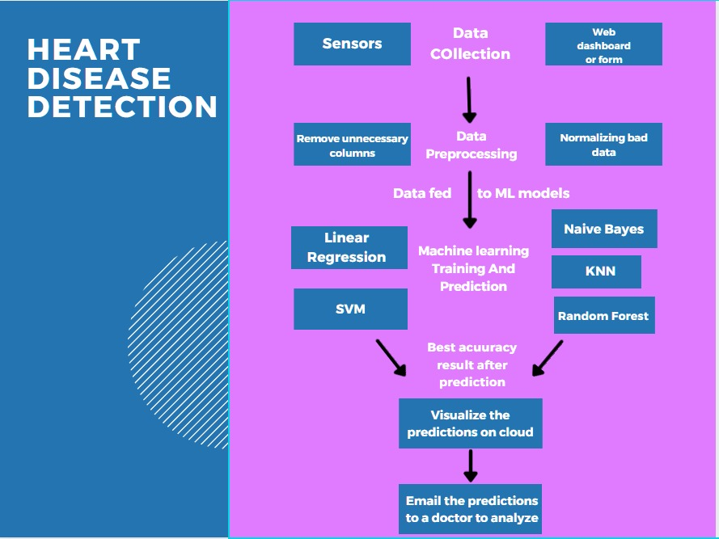ML models algorithms are being run on dataset and accurately predicted dataset is passed onto IoT cloud for storage and visualization

**Working Modules**

**Module 1 – ML Model Implementation**

* 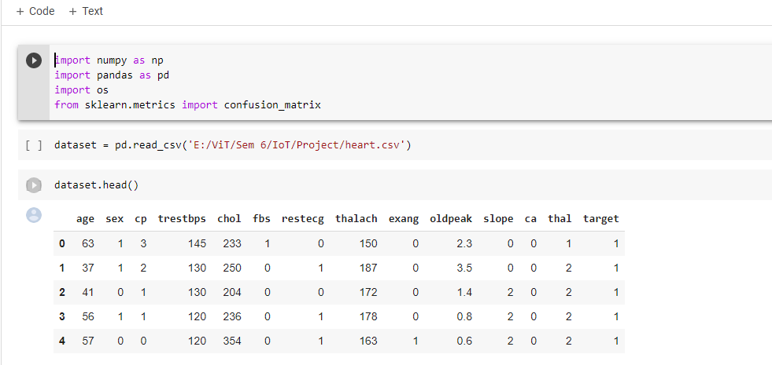**Importing necessary and essential libraries for performing various analysis on the dataset taken( Heart.csv)**
* **Description and attributes of the dataset**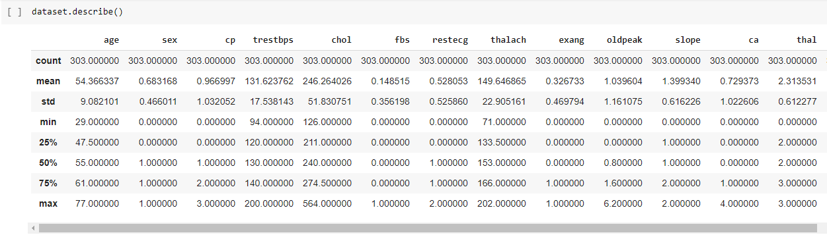
* **One Hot encoding(categorical variables changes)**
  + - 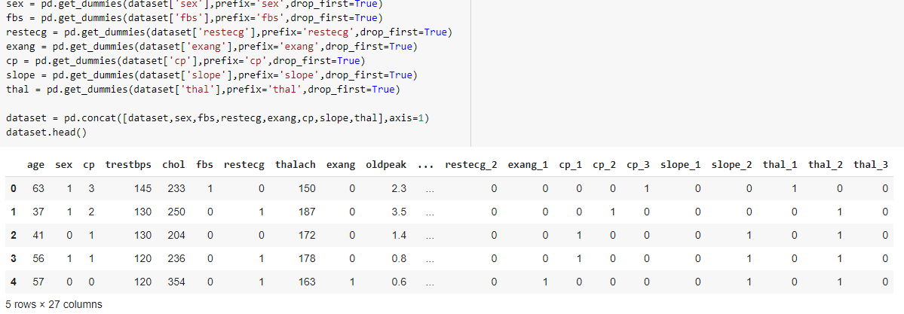Example restecg changes to restecg_2 etc
* **Target variable drops and changes to x**
* 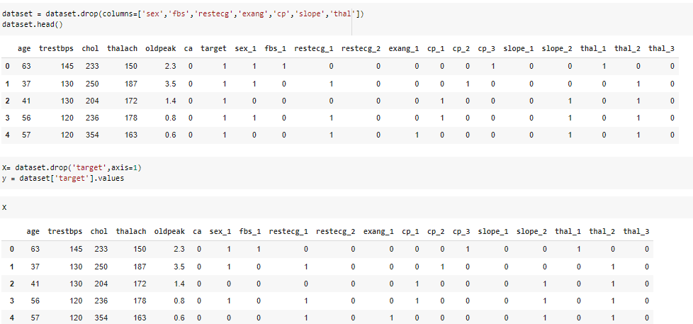**Target variable makes y variable**
* 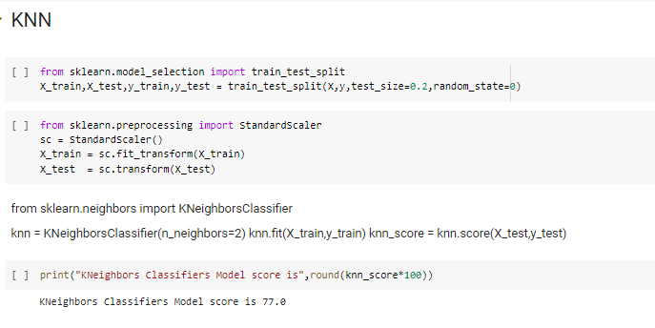**KNN is being implemented here**

**Accuracy :- 77 %**

* **Logistic Regression is being implemented here**

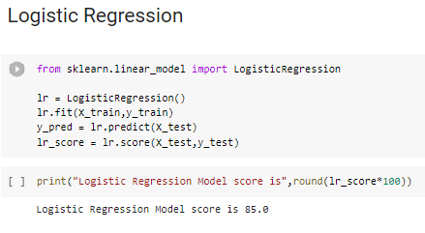

**Accuracy : - 85 %**

* **Support Vector is applied here**

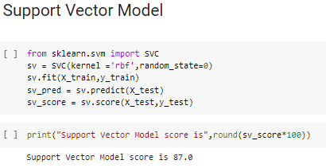

**Accuracy :- 87 %**

* **Random Forest is applied here**

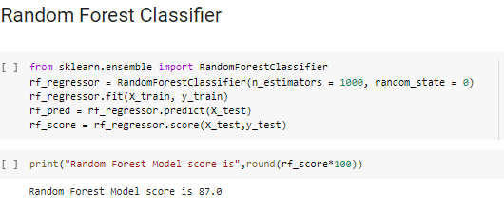

**Accuracy :- 87 %**

* **Naives Bayes is being implemented here**

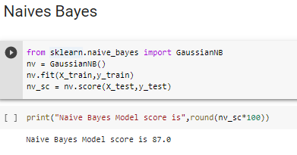

**Accuracy :- 87 %**

* **Performed Cross Validation for computing mean accuracies of various models**

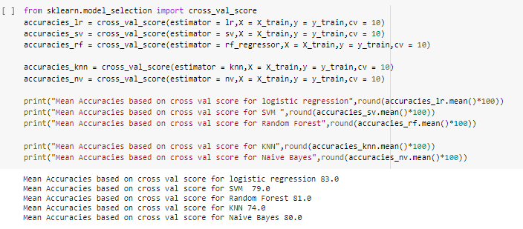

* Making Data Frames of all models and visualizing them

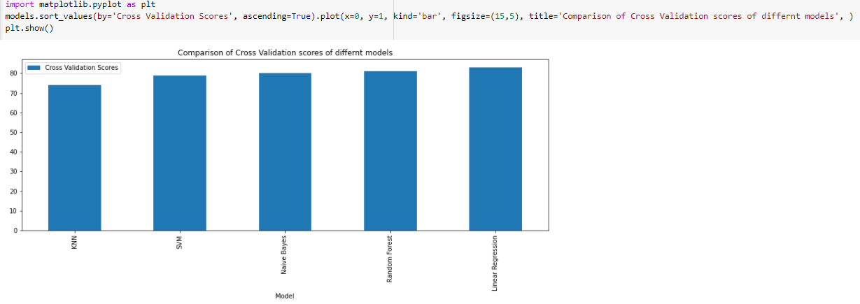

**“Therefore ,the model we chose is “Random Forest” as it gave us more optimized results.Now dataset is being transferred from nodered to python notebook to be trained on Random forest model”**

* **CSV generated from nodered named “t3.csv”**

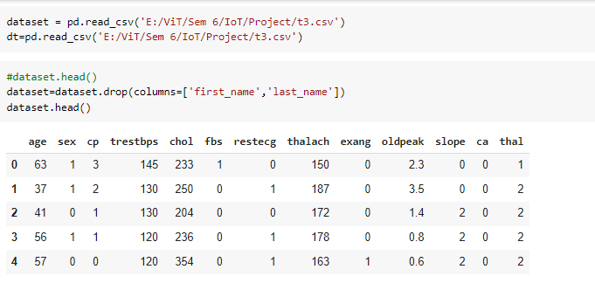

* Prediction on target variable gives

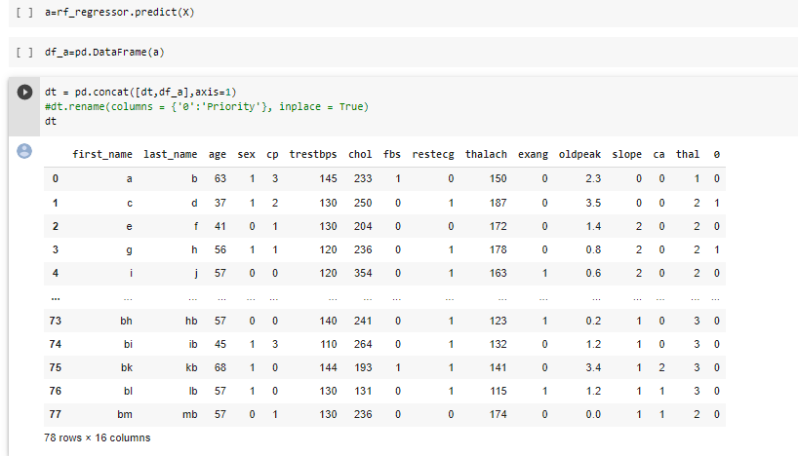

* File saved as file_name.csv

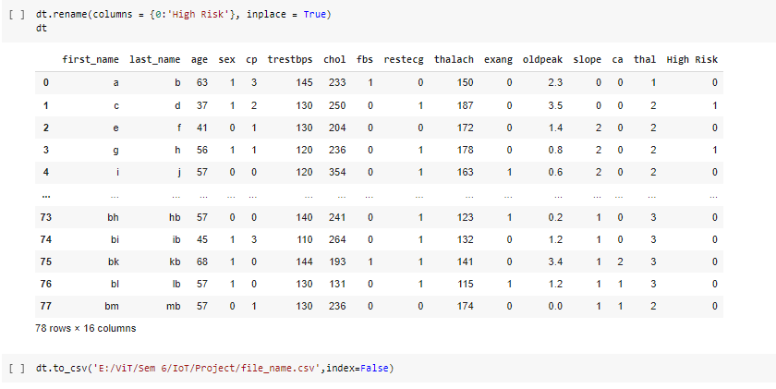

* 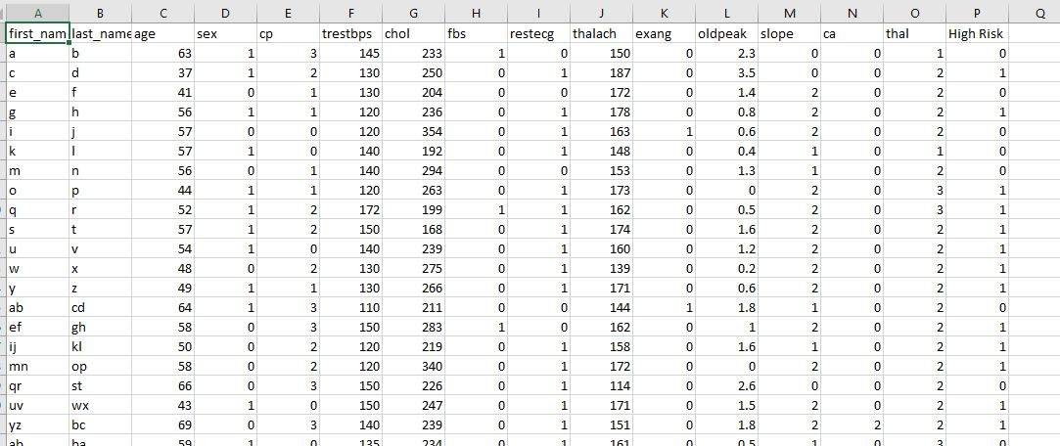Displaying final parametric dataset named file_name.csv

**Module 2 – Node-Red Implementation**

* Inputs are taken in the form
* Values of parameters mentioned in the UI form will be displayed in debug UI using function nodes
* These values are then displayed on dashboard UI (Ex:- Patient Name node)
* Three values Restbps,cholesterol,blood sugar level are taken directly from sensor
* These values are transmitted into file node( Ex:- nrf.csv)
* Deploy the flow
* Fill values in form
* Displayed in LCD Panel
* 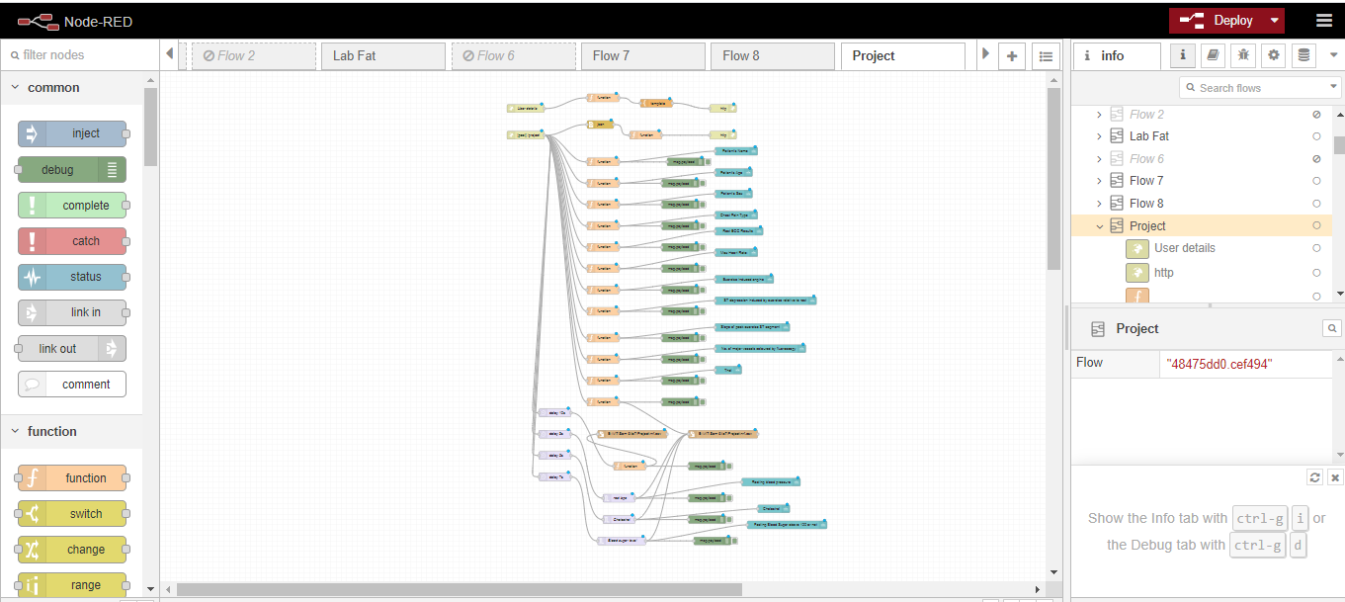With help of file node,it will get into csv file

**Flow Diagram**

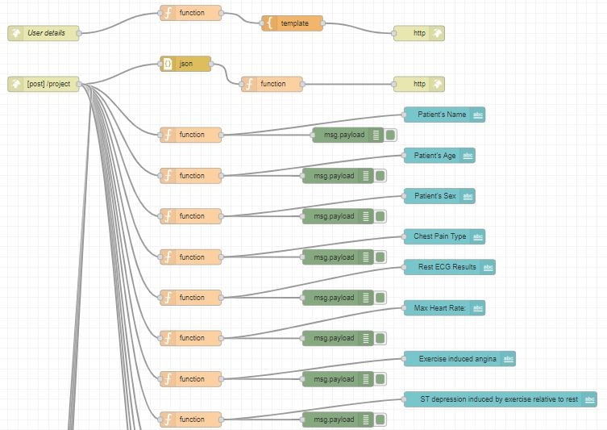

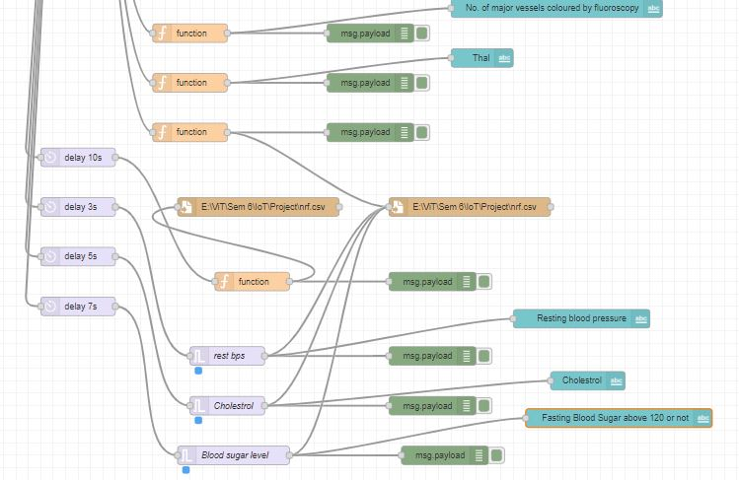

**Email Flow**

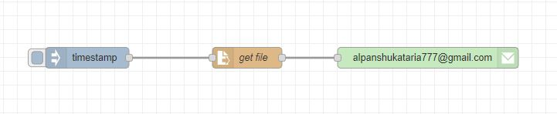

**UI (Form for fetching patient vital inputs)**

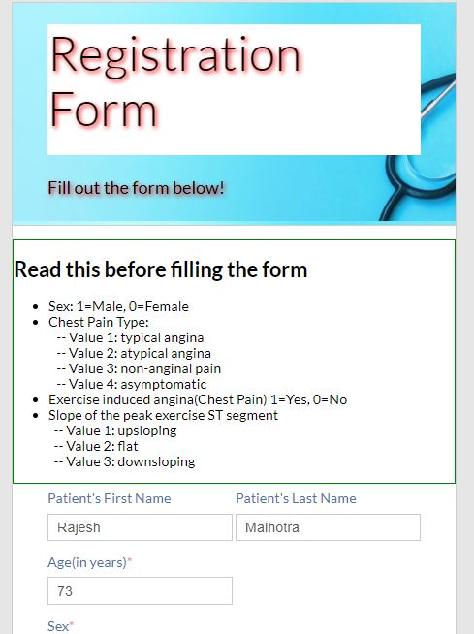

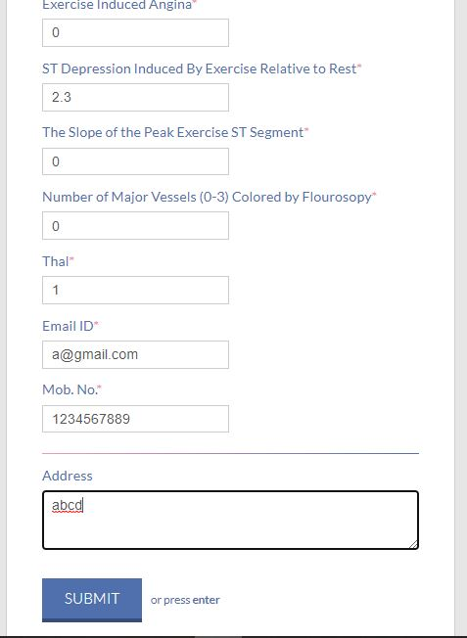

**Dashboard UI**

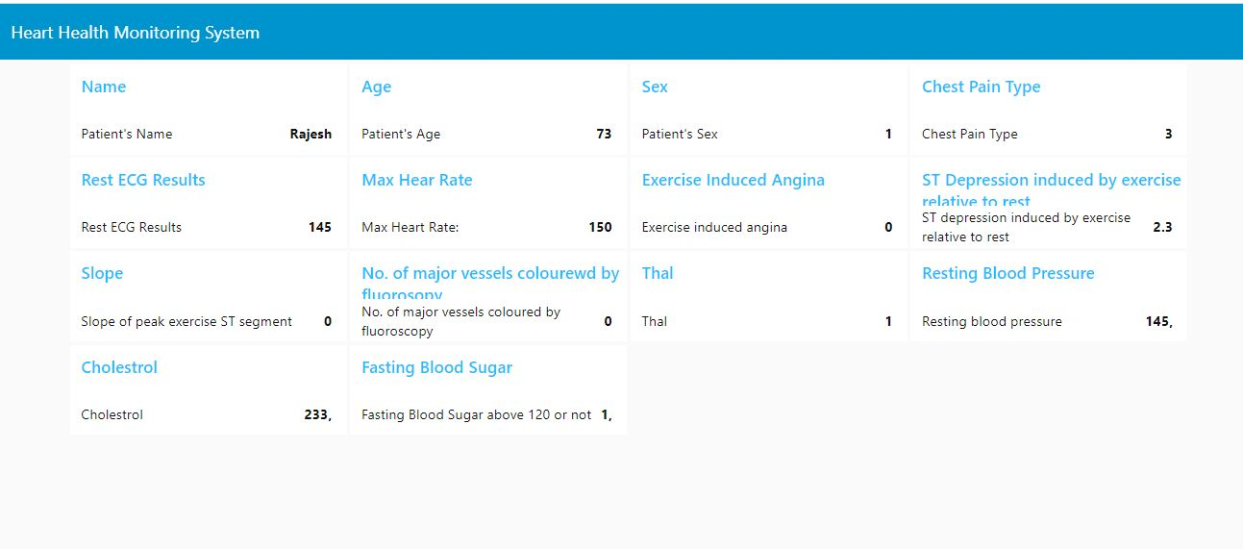**EMAIL (For accessing csv file)**

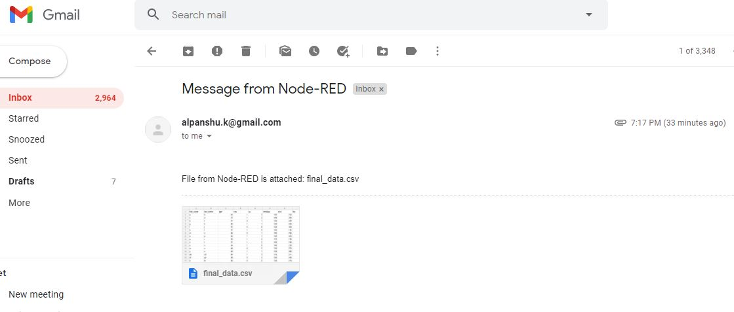

**Module 3 – Azure PowerBi Cloud Implementation**

ThePowerBI app component of Microsoft azure cloud is used to visualize the predicted heart disease risk along with different columns for generalization.The predicted data can be then sent to a doctor through email node of node red.The doctor can then derive appropriate insights from the predicted data and data visualizations of the predicted data on the cloud.

The predicted dataset final.csv is then passed to Microsoft Azure IoT in PowerBi component and then analyzed which is shown below.

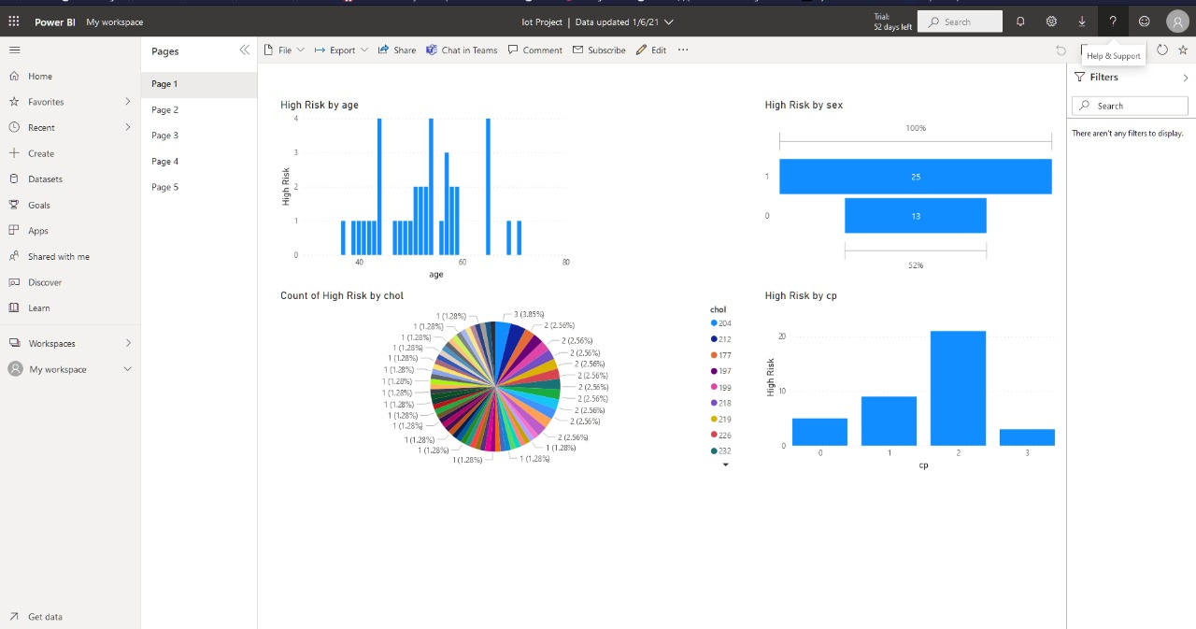

* **Visualization comparing age of patient against their ages**

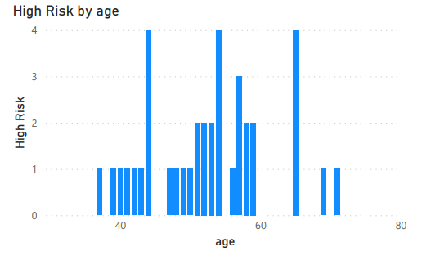

* **Visualization showing high risk by sex**

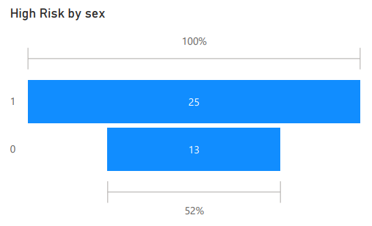

* **Precisely showing count of high risk based on Cholestrol**

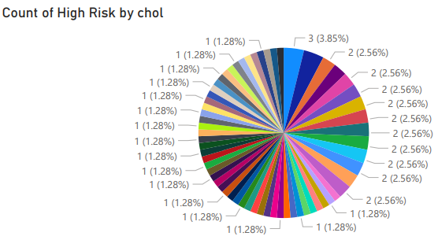

* **High risk based on chest pain symptom**

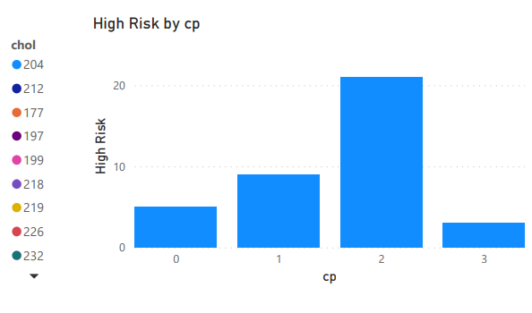

* 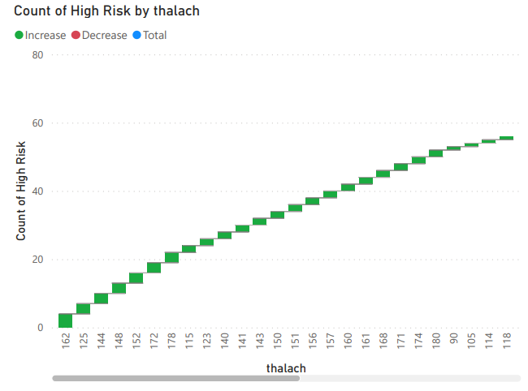**Count of high risk based on Max heart rate achieved**
* **Count of high risk based on resting blood pressure**

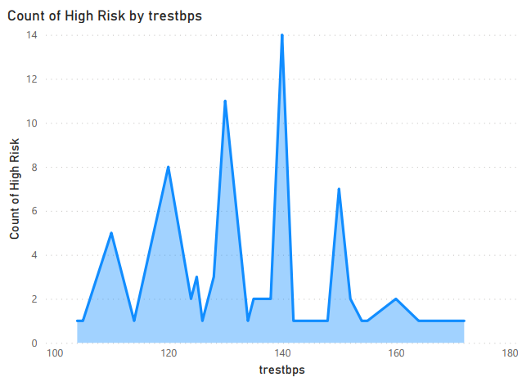

* **Count of high risk based on fasting blood pressure**

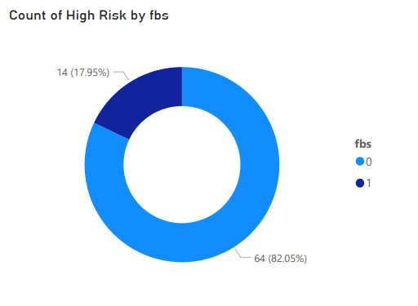

* **Count of high risk based on resting electrocardiographic results**

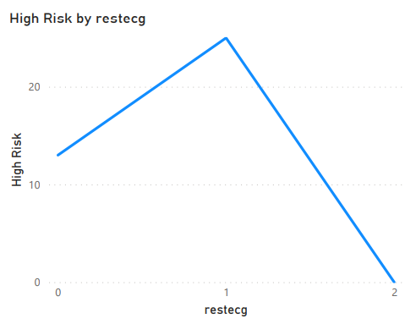

* 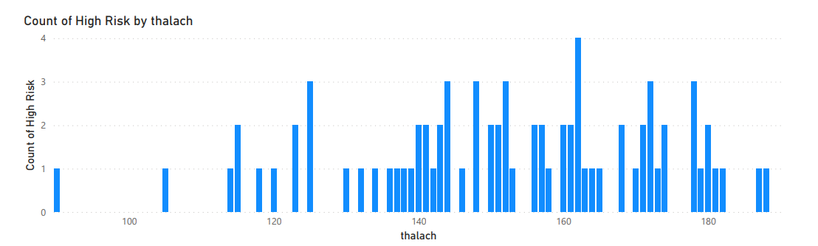**Count of high risk based on resting electrocardiographic results**
* **Count of high risk based on ST depression induced by rest exercise**

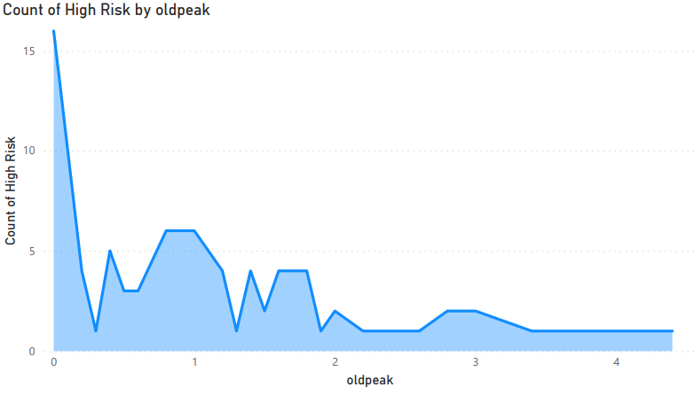

* **Count of high risk based on exercise induced angina**

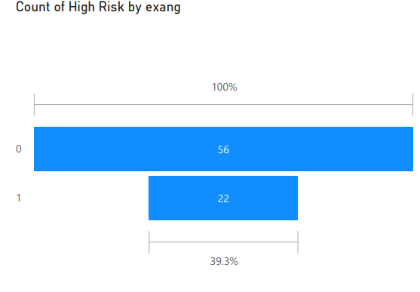

* **Count of high risk based on number of major vessels**

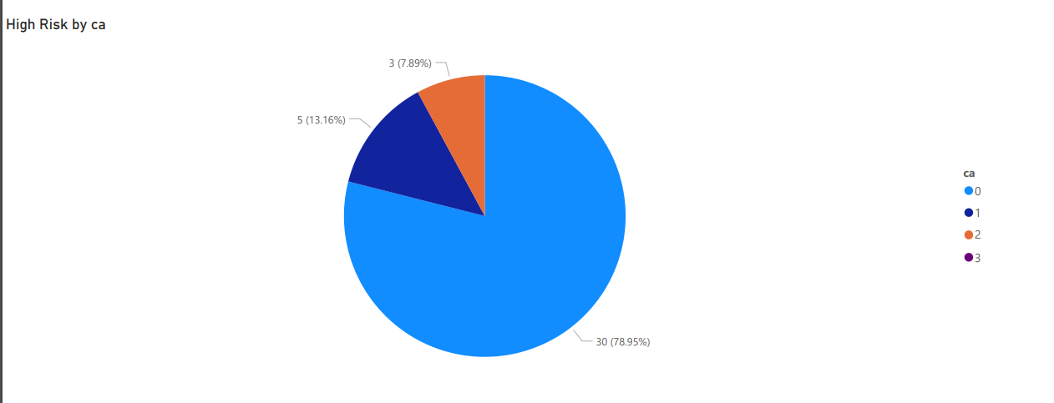

**Program Code**

* **Python Code**

#!/usr/bin/env python

# coding: utf-8

# In[1]:

import numpy as np

import pandas as pd

import os

from sklearn.metrics import confusion_matrix

# In[2]:

dataset = pd.read_csv('E:/ViT/Sem 6/IoT/Project/heart.csv')

# In[3]:

dataset.head()

# In[4]:

dataset.info()

# In[5]:

dataset.describe()

# In[6]:

dataset.shape

# In[7]:

sex = pd.get_dummies(dataset['sex'],prefix='sex',drop_first=True)

fbs = pd.get_dummies(dataset['fbs'],prefix='fbs',drop_first=True)

restecg = pd.get_dummies(dataset['restecg'],prefix='restecg',drop_first=True)

exang = pd.get_dummies(dataset['exang'],prefix='exang',drop_first=True)

cp = pd.get_dummies(dataset['cp'],prefix='cp',drop_first=True)

slope = pd.get_dummies(dataset['slope'],prefix='slope',drop_first=True)

thal = pd.get_dummies(dataset['thal'],prefix='thal',drop_first=True)

dataset = pd.concat([dataset,sex,fbs,restecg,exang,cp,slope,thal],axis=1)

dataset.head()

# In[8]:

dataset = dataset.drop(columns=['sex','fbs','restecg','exang','cp','slope','thal'])

dataset.head()

# In[9]:

X= dataset.drop('target',axis=1)

y = dataset['target'].values

# In[10]:

X

# # KNN

# In[11]:

from sklearn.model_selection import train_test_split

X_train,X_test,y_train,y_test = train_test_split(X,y,test_size=0.2,random_state=0)

# In[12]:

from sklearn.preprocessing import StandardScaler

sc = StandardScaler()

X_train = sc.fit_transform(X_train)

X_test = sc.transform(X_test)

# from sklearn.neighbors import KNeighborsClassifier

#

# knn = KNeighborsClassifier(n_neighbors=2)

# knn.fit(X_train,y_train)

# knn_score = knn.score(X_test,y_test)

# In[14]:

print("KNeighbors Classifiers Model score is",round(knn_score*100))

# # Logistic Regression

# In[15]:

from sklearn.linear_model import LogisticRegression

lr = LogisticRegression()

lr.fit(X_train,y_train)

y_pred = lr.predict(X_test)

lr_score = lr.score(X_test,y_test)

# In[16]:

print("Logistic Regression Model score is",round(lr_score*100))

# # Support Vector Model

# In[17]:

from sklearn.svm import SVC

sv = SVC(kernel ='rbf',random_state=0)

sv.fit(X_train,y_train)

sv_pred = sv.predict(X_test)

sv_score = sv.score(X_test,y_test)

# In[18]:

print("Support Vector Model score is",round(sv_score*100))

# # Random Forest Classifier

# In[19]:

from sklearn.ensemble import RandomForestClassifier

rf_regressor = RandomForestClassifier(n_estimators = 1000, random_state = 0)

rf_regressor.fit(X_train, y_train)

rf_pred = rf_regressor.predict(X_test)

rf_score = rf_regressor.score(X_test,y_test)

# In[20]:

print("Random Forest Model score is",round(rf_score*100))

# In[21]:

from sklearn.naive_bayes import GaussianNB

nv = GaussianNB()

nv.fit(X_train,y_train)

nv_sc = nv.score(X_test,y_test)

# In[22]:

print("Naive Bayes Model score is",round(nv_sc*100))

# In[23]:

from sklearn.model_selection import cross_val_score

accuracies_lr = cross_val_score(estimator = lr,X = X_train,y = y_train,cv = 10)

accuracies_sv = cross_val_score(estimator = sv,X = X_train,y = y_train,cv = 10)

accuracies_rf = cross_val_score(estimator = rf_regressor,X = X_train,y = y_train,cv = 10)

accuracies_knn = cross_val_score(estimator = knn,X = X_train,y = y_train,cv = 10)

accuracies_nv = cross_val_score(estimator = nv,X = X_train,y = y_train,cv = 10)

print("Mean Accuracies based on cross val score for logistic regression",round(accuracies_lr.mean()*100))

print("Mean Accuracies based on cross val score for SVM ",round(accuracies_sv.mean()*100))

print("Mean Accuracies based on cross val score for Random Forest",round(accuracies_rf.mean()*100))

print("Mean Accuracies based on cross val score for KNN",round(accuracies_knn.mean()*100))

print("Mean Accuracies based on cross val score for Naive Bayes",round(accuracies_nv.mean()*100))

# In[24]:

models = pd.DataFrame({

'Model': ['Linear Regression', 'SVM', 'Random Forest', 'KNN','Naive Bayes'],

'Cross Validation Scores': [round(accuracies_lr.mean()*100), round(accuracies_sv.mean()*100), round(accuracies_rf.mean()*100), round(accuracies_knn.mean()*100),round(accuracies_nv.mean()*100)]})

models.sort_values(by='Cross Validation Scores', ascending=False)

# In[25]:

import matplotlib.pyplot as plt

models.sort_values(by='Cross Validation Scores', ascending=True).plot(x=0, y=1, kind='bar', figsize=(15,5), title='Comparison of Cross Validation scores of differnt models', )

plt.show()

# In[65]:

dataset = pd.read_csv('E:/ViT/Sem 6/IoT/Project/t3.csv')

dt=pd.read_csv('E:/ViT/Sem 6/IoT/Project/t3.csv')

# In[66]:

#dataset.head()

dataset=dataset.drop(columns=['first_name','last_name'])

dataset.head()

# In[67]:

sex = pd.get_dummies(dataset['sex'],prefix='sex',drop_first=True)

fbs = pd.get_dummies(dataset['fbs'],prefix='fbs',drop_first=True)

restecg = pd.get_dummies(dataset['restecg'],prefix='restecg',drop_first=True)

exang = pd.get_dummies(dataset['exang'],prefix='exang',drop_first=True)

cp = pd.get_dummies(dataset['cp'],prefix='cp',drop_first=True)

slope = pd.get_dummies(dataset['slope'],prefix='slope',drop_first=True)

thal = pd.get_dummies(dataset['thal'],prefix='thal',drop_first=True)

dataset = pd.concat([dataset,sex,fbs,restecg,exang,cp,slope,thal],axis=1)

#dataset.head()

# In[68]:

dataset = dataset.drop(columns=['sex','fbs','restecg','exang','cp','slope','thal'])

# In[69]:

#X= dataset.drop('target',axis=1)

X= dataset

X

# In[70]:

a=rf_regressor.predict(X)

# In[71]:

df_a=pd.DataFrame(a)

# In[72]:

dt = pd.concat([dt,df_a],axis=1)

#dt.rename(columns = {'0':'Priority'}, inplace = True)

dt

# In[74]:

dt.rename(columns = {0:'High Risk'}, inplace = True)

dt

# In[75]:

dt.to_csv('E:/ViT/Sem 6/IoT/Project/file_name.csv',index=False)

# In[ ]:

**#End of code**

* **Node-red Code**

[{"id":"48475dd0.cef494","type":"tab","label":"final","disabled":false,"info":""},{"id":"2f987a05.97bbc6","type":"http in","z":"48475dd0.cef494","name":"User details","url":"/def","method":"get","upload":false,"swaggerDoc":"","x":130,"y":80,"wires":[["14d1423c.e166fe"]]},{"id":"26b22083.b3b74","type":"http response","z":"48475dd0.cef494","name":"","statusCode":"","headers":{},"x":870,"y":80,"wires":[]},{"id":"14d1423c.e166fe","type":"function","z":"48475dd0.cef494","name":"","func":"msg.url=\"index\";\nreturn msg;","outputs":1,"noerr":0,"initialize":"","finalize":"","x":420,"y":40,"wires":[["2a315831.7a1618"]]},{"id":"2a315831.7a1618","type":"template","z":"48475dd0.cef494","name":"","field":"payload","fieldType":"msg","format":"html","syntax":"mustache","template":"<!DOCTYPE html>\n<html lang=\"en\" >\n<head>\n<meta charset=\"UTF-8\">\n<title>Registration Form</title>\n<meta name=\"viewport\" content=\"width=device-width, initial-scale=1.0\">\n<link rel=\"stylesheet\" href=\"https://cdnjs.cloudflare.com/ajax/libs/normalize/5.0.0/normalize.min.css\">\n<style>\n@import url(https://fonts.googleapis.com/css?family=Lato:300,400,700);\n body {\nbackground-color: #e6e6e6;\nfont-size: 100%;\nfont-family: 'Lato', sans-serif;\nfont-weight: 400;\n}\ndiv, textarea, input {\n-moz-box-sizing: border-box;\n-webkit-box-sizing: border-box;\nbox-sizing: border-box;\n}\n.boxed {\n border: 1px solid green ;\n}\n.container {\nmax-width: 510px;\nmin-width: 324px;\nmargin: 50px auto 0px;\nbackground-color: #fff;\nborder: 1px solid #cfcfcf;\nborder-bottom: 3px solid #ccc;\n}\n.row {\nwidth: 100%;\nmargin: 0 0 1em 0;\npadding: 0 2.5em;\n}\n.row.header {\npadding: 1.5em 2.5em;\nborder-bottom: 1px solid #ccc;\nbackground: url('https://www.cpajournal.com/wp-content/uploads/2019/02/GettyImages-1001713236-730x330.jpg') left -80px;\ncolor: #fff;\n}\n.row.body {\npadding: .5em 2.5em 1em;\n}\n.pull-right {\nfloat: right;\n}\nh1 {\nfont-family: 'Lato', sans-serif;\nfont-weight: 300;\ndisplay: inline-block;\nfont-weight: 100;\n background-color: white;\ncolor: black;\ntext-shadow: 2px 2px 5px red;\nfont-size: 3.5em;\nborder-bottom: 1px solid rgba(255, 255, 255, 0.3);\nmargin: 0 0 0.1em 0;\npadding: 0 0 0.4em 0;\n}\nh3 {\nfont-family: 'Lato', sans-serif;\nfont-weight: 400;\nfont-size: 1.25em;\ncolor: black;\ntext-shadow: 2px 2px 5px red;\nmargin: 1em 0 0.4em 0;\n}\n.btn {\nfont-size: 1.0625em;\ndisplay: inline-block;\npadding: 0.74em 1.5em;\nmargin: 1.5em 0 0;\ncolor: #fff;\nborder-width: 0 0 0 0;\nborder-bottom: 5px solid;\ntext-transform: uppercase;\nbackground-color: #b3b3b3;\nborder-bottom-color: #8c8c8c;\nfont-family: 'Lato', sans-serif;\nfont-weight: 300;\n}\n.btn:hover {\nbackground-color: #bfbfbf;\n}\n.btn.btn-submit {\nbackground-color: #4f6fad;\nborder-bottom-color: #374d78;\n}\n.btn.btn-submit:hover {\nbackground-color: #5f7db6;\n}\nform {\nmax-width: 100%;\n display: block;\n}\nform ul {\nmargin: 0;\npadding: 0;\nlist-style: none;\n}\nform ul li {\nmargin: 0 0 0.25em 0;\nclear: both;\ndisplay: inline-block;\nwidth: 100%;\n}\nform ul li:last-child {\nmargin: 0;\n}\nform ul li p {\nmargin: 0;\npadding: 0;\nfloat: left;\n}\nform ul li p.right {\nfloat: right;\n}\nform ul li .divider {\nmargin: 0.5em 0 0.5em 0;\nborder: 0;\nheight: 1px;\nwidth: 100%;\ndisplay: block;\nbackground-color: #4f6fad;\nbackground-image: linear-gradient(to right, #ee9cb4, #4f6fad);\n}\nform ul li .req {\ncolor: #ee9cb4;\n}\nform label {\ndisplay: block;\nmargin: 0 0 0.5em 0;\ncolor: #4f6fad;\nfont-size: 1em;\n}\n form input {\nmargin: 0 0 0.5em 0;\nborder: 1px solid #ccc;\npadding: 6px 10px;\ncolor: #555;\nfont-size: 1em;\n}\nform textarea {\nborder: 1px solid #ccc;\npadding: 6px 10px;\nwidth: 100%;\ncolor: #555;\n}\nform small {\ncolor: #4f6fad;\nmargin: 0 0 0 0.5em;\n}\n@media only screen and (max-width: 480px) {\n.pull-right {\nfloat: none;\n}\ninput {\nwidth: 100%;\n}\nlabel {\nwidth: 100%;\ndisplay: inline-block;\nfloat: left;\nclear: both;\n}\nli, p {\nwidth: 100%;\n}\ninput.btn {\nmargin: 1.5em 0 0.5em;\n}\nh1 {\nfont-size: 2.25em;\n}\nh3 {\nfont-size: 1.125em;\n }\nli small {\ndisplay: none;\n}\n}\n</style>\n</head>\n<body>\n<!-- partial:index.partial.html -->\n<div class=\"container\">\n<div class=\"row header\">\n<h1>Registration Form &nbsp;</h1>\n<h3>Fill out the form below!</h3>\n</div>\n<div class=\"boxed\">\n <h2>Read this before filling the form</h2>\n<ul>\n <li>Sex: 1=Male, 0=Female</li>\n <li>Chest Pain Type: </li>\n &nbsp;&nbsp; -- Value 1: typical angina<br>\n &nbsp;&nbsp; -- Value 2: atypical angina<br>\n &nbsp;&nbsp; -- Value 3: non-anginal pain<br>\n &nbsp;&nbsp; -- Value 4: asymptomatic\n <li>Exercise induced angina(Chest Pain) 1=Yes, 0=No</li>\n <li>Slope of the peak exercise ST segment</li>\n &nbsp;&nbsp;-- Value 1: upsloping<br>\n &nbsp;&nbsp;-- Value 2: flat<br>\n &nbsp;&nbsp;-- Value 3: downsloping\n</ul>\n</div>\n<div class=\"row body\">\n<form method=\"post\" action=\"/project\">\n<ul>\n<li>\n<p class=\"left\">\n<label for=\"patient_first_name\">Patient's First Name</label>\n<input type=\"text\" name=\"patient_first_name\" />\n</p>\n<p class=\"pull-right\">\n<label for=\"patient_last_name\">Patient's Last Name</label>\n<input type=\"text\" name=\"patient_last_name\" />\n</p>\n</li>\n\n<li>\n<p>\n<label for=\"age\">Age(in years)<span class=\"req\">*</span></label>\n<input type=\"age\" name=\"age\" />\n</p>\n</li>\n\n<li>\n<p>\n<label for=\"sex\">Sex<span class=\"req\">*</span></label>\n<input type=\"sex\" name=\"sex\" />\n</p>\n</li>\n\n<li>\n<p>\n<label for=\"chest_pain_type\">Chest Pain Type<span class=\"req\">*</span></label>\n<input type=\"chest_pain_type\" name=\"chest_pain_type\" />\n</p>\n</li>\n\n<li>\n<p>\n<label for=\"rest_ecg_results\">Resting ECG Results<span class=\"req\">*</span></label>\n<input type=\"rest_ecg_results\" name=\"rest_ecg_results\" />\n</p>\n</li>\n\n<li>\n<p>\n<label for=\"max_heartrate\">Maximum Heart Rate Achieved<span class=\"req\">*</span></label>\n<input type=\"max_heartrate\" name=\"max_heartrate\" />\n</p>\n</li>\n\n<li>\n<p>\n<label for=\"exang\">Exercise Induced Angina<span class=\"req\">*</span></label>\n<input type=\"exang\" name=\"exang\" />\n</p>\n</li>\n\n<li>\n<p>\n<label for=\"oldpeak\">ST Depression Induced By Exercise Relative to Rest<span class=\"req\">*</span></label>\n<input type=\"oldpeak\" name=\"oldpeak\" />\n</p>\n</li>\n\n<li>\n<p>\n<label for=\"slope\">The Slope of the Peak Exercise ST Segment<span class=\"req\">*</span></label>\n<input type=\"slope\" name=\"slope\" />\n</p>\n</li>\n\n<li>\n<p>\n<label for=\"ca\">Number of Major Vessels (0-3) Colored by Flourosopy<span class=\"req\">*</span></label>\n<input type=\"ca\" name=\"ca\" />\n</p>\n</li>\n\n<li>\n<p>\n<label for=\"thal\">Thal<span class=\"req\">*</span></label>\n<input type=\"thal\" name=\"thal\" />\n</p>\n</li>\n\n<li>\n<p>\n<label for=\"email\">Email ID<span class=\"req\">*</span></label>\n<input type=\"email\" name=\"email\" />\n</p>\n</li>\n<li>\n<p>\n<label for=\"Mob_No\">Mob. No.<span class=\"req\">*</span></label>\n<input type=\"Mob_No\" name=\"Mob_No\" />\n</p>\n</li>\n\n<li><div class=\"divider\"></div></li>\n<li>\n<label for=\"Address\">Address</label>\n<textarea cols=\"46\" rows=\"3\" name=\"Address\"></textarea>\n</li>\n <li>\n <input class=\"btn btn-submit\" type=\"submit\" value=\"Submit\" />\n <small>or press <strong>enter</strong></small>\n </li>\n</ul>\n</form>\n</div>\n</div>\n<!-- partial -->\n</body>\n</html>","output":"str","x":620,"y":60,"wires":[["26b22083.b3b74"]]},{"id":"f0a28d9c.946f4","type":"http in","z":"48475dd0.cef494","name":"","url":"/project","method":"post","upload":false,"swaggerDoc":"","x":130,"y":180,"wires":[["22fa4f5c.98e39","3959dc82.45ee34","9f2913f2.42ecd","73c44fb2.010fe","fbc3f290.fed79","af65fcef.3d769","d948790a.bf91c8","ec9a6351.6e4fb","b06767e0.a13a98","af315f47.42be7","6fa1319d.335f","30737dea.dab762","bba12b0a.1916a8","cd6a854a.6b7138","823a330a.5739f","715593a8.6238cc","5b1c0b31.1eb414"]]},{"id":"6efd2be4.9cb9b4","type":"function","z":"48475dd0.cef494","name":"","func":"return msg;","outputs":1,"noerr":0,"initialize":"","finalize":"","x":580,"y":180,"wires":[["e1dacde0.c5352"]]},{"id":"e1dacde0.c5352","type":"http response","z":"48475dd0.cef494","name":"","statusCode":"","headers":{},"x":870,"y":180,"wires":[]},{"id":"22fa4f5c.98e39","type":"json","z":"48475dd0.cef494","name":"","property":"payload","action":"","pretty":false,"x":410,"y":140,"wires":[["6efd2be4.9cb9b4"]]},{"id":"5b1c0b31.1eb414","type":"function","z":"48475dd0.cef494","name":"","func":"msg.payload=msg.payload.patient_first_name+\",\"+msg.payload.patient_last_name+\",\"+msg.payload.age+\",\"+msg.payload.sex+\",\"+msg.payload.chest_pain_type+\",\";\nreturn msg;","outputs":1,"noerr":0,"initialize":"","finalize":"","x":420,"y":1180,"wires":[["90223f70.cf667","f4df5f06.c169a"]]},{"id":"3959dc82.45ee34","type":"function","z":"48475dd0.cef494","name":"","func":"msg.payload=msg.payload.patient_first_name;\nreturn msg;","outputs":1,"noerr":0,"initialize":"","finalize":"","x":420,"y":280,"wires":[["5e81f67a.299fc8","cce2288d.01e098"]]},{"id":"5e81f67a.299fc8","type":"debug","z":"48475dd0.cef494","name":"","active":true,"tosidebar":true,"console":false,"tostatus":false,"complete":"false","statusVal":"","statusType":"auto","x":730,"y":280,"wires":[]},{"id":"9f2913f2.42ecd","type":"function","z":"48475dd0.cef494","name":"","func":"msg.payload=msg.payload.age;\nreturn msg;","outputs":1,"noerr":0,"initialize":"","finalize":"","x":420,"y":360,"wires":[["345763ec.cb75bc","5bd92786.1a8bb8"]]},{"id":"345763ec.cb75bc","type":"debug","z":"48475dd0.cef494","name":"","active":true,"tosidebar":true,"console":false,"tostatus":false,"complete":"payload","targetType":"msg","statusVal":"","statusType":"auto","x":710,"y":360,"wires":[]},{"id":"73c44fb2.010fe","type":"function","z":"48475dd0.cef494","name":"","func":"msg.payload=msg.payload.sex;\nreturn msg;","outputs":1,"noerr":0,"initialize":"","finalize":"","x":420,"y":440,"wires":[["c07aa910.12d258","96d90711.c97f48"]]},{"id":"c07aa910.12d258","type":"debug","z":"48475dd0.cef494","name":"","active":true,"tosidebar":true,"console":false,"tostatus":false,"complete":"false","statusVal":"","statusType":"auto","x":710,"y":440,"wires":[]},{"id":"fbc3f290.fed79","type":"function","z":"48475dd0.cef494","name":"","func":"msg.payload=msg.payload.chest_pain_type;\nreturn msg;","outputs":1,"noerr":0,"initialize":"","finalize":"","x":420,"y":520,"wires":[["23d00c31.aec484","3202b7c3.a5b2f8"]]},{"id":"23d00c31.aec484","type":"debug","z":"48475dd0.cef494","name":"","active":true,"tosidebar":true,"console":false,"tostatus":false,"complete":"false","statusVal":"","statusType":"auto","x":710,"y":520,"wires":[]},{"id":"af65fcef.3d769","type":"function","z":"48475dd0.cef494","name":"","func":"msg.payload=msg.payload.rest_ecg_results;\nreturn msg;","outputs":1,"noerr":0,"initialize":"","finalize":"","x":420,"y":600,"wires":[["f361c6ff.b57ed8","a0faee08.a11e8"]]},{"id":"f361c6ff.b57ed8","type":"debug","z":"48475dd0.cef494","name":"","active":true,"tosidebar":true,"console":false,"tostatus":false,"complete":"false","statusVal":"","statusType":"auto","x":710,"y":600,"wires":[]},{"id":"d948790a.bf91c8","type":"function","z":"48475dd0.cef494","name":"","func":"msg.payload=msg.payload.max_heartrate;\nreturn msg;","outputs":1,"noerr":0,"initialize":"","finalize":"","x":420,"y":680,"wires":[["9d7f4d6f.10502","db233c93.db34d"]]},{"id":"9d7f4d6f.10502","type":"debug","z":"48475dd0.cef494","name":"","active":true,"tosidebar":true,"console":false,"tostatus":false,"complete":"false","statusVal":"","statusType":"auto","x":710,"y":680,"wires":[]},{"id":"ec9a6351.6e4fb","type":"function","z":"48475dd0.cef494","name":"","func":"msg.payload=msg.payload.exang;\nreturn msg;","outputs":1,"noerr":0,"initialize":"","finalize":"","x":420,"y":760,"wires":[["acd5f5ba.b4f098","70aa7817.768428"]]},{"id":"acd5f5ba.b4f098","type":"debug","z":"48475dd0.cef494","name":"","active":true,"tosidebar":true,"console":false,"tostatus":false,"complete":"false","statusVal":"","statusType":"auto","x":710,"y":760,"wires":[]},{"id":"b06767e0.a13a98","type":"function","z":"48475dd0.cef494","name":"","func":"msg.payload=msg.payload.oldpeak;\nreturn msg;","outputs":1,"noerr":0,"initialize":"","finalize":"","x":420,"y":840,"wires":[["bc2ec941.7c7c08","7841f13f.8a4f3"]]},{"id":"bc2ec941.7c7c08","type":"debug","z":"48475dd0.cef494","name":"","active":true,"tosidebar":true,"console":false,"tostatus":false,"complete":"false","statusVal":"","statusType":"auto","x":710,"y":840,"wires":[]},{"id":"af315f47.42be7","type":"function","z":"48475dd0.cef494","name":"","func":"msg.payload=msg.payload.slope;\nreturn msg;","outputs":1,"noerr":0,"initialize":"","finalize":"","x":420,"y":940,"wires":[["ec1be3c.ad8172","eb4d1208.e1007"]]},{"id":"ec1be3c.ad8172","type":"debug","z":"48475dd0.cef494","name":"","active":true,"tosidebar":true,"console":false,"tostatus":false,"complete":"false","statusVal":"","statusType":"auto","x":710,"y":940,"wires":[]},{"id":"6fa1319d.335f","type":"function","z":"48475dd0.cef494","name":"","func":"msg.payload=msg.payload.ca;\nreturn msg;","outputs":1,"noerr":0,"initialize":"","finalize":"","x":420,"y":1020,"wires":[["aad7bb97.c33178","b72c0448.8a3178"]]},{"id":"aad7bb97.c33178","type":"debug","z":"48475dd0.cef494","name":"","active":true,"tosidebar":true,"console":false,"tostatus":false,"complete":"false","statusVal":"","statusType":"auto","x":710,"y":1020,"wires":[]},{"id":"30737dea.dab762","type":"function","z":"48475dd0.cef494","name":"","func":"msg.payload=msg.payload.thal;\nreturn msg;","outputs":1,"noerr":0,"initialize":"","finalize":"","x":420,"y":1100,"wires":[["47f73dbb.5f75f4","8e0ae7a5.49b508"]]},{"id":"47f73dbb.5f75f4","type":"debug","z":"48475dd0.cef494","name":"","active":true,"tosidebar":true,"console":false,"tostatus":false,"complete":"false","statusVal":"","statusType":"auto","x":710,"y":1100,"wires":[]},{"id":"f4df5f06.c169a","type":"file","z":"48475dd0.cef494","name":"","filename":"E:\\ViT\\Sem 6\\IoT\\Project\\nrf.csv","appendNewline":false,"createDir":false,"overwriteFile":"false","encoding":"none","x":870,"y":1300,"wires":[[]]},{"id":"bba12b0a.1916a8","type":"delay","z":"48475dd0.cef494","name":"","pauseType":"delay","timeout":"10","timeoutUnits":"seconds","rate":"1","nbRateUnits":"1","rateUnits":"second","randomFirst":"1","randomLast":"5","randomUnits":"seconds","drop":false,"x":240,"y":1220,"wires":[["ad1eaa94.fd12a8"]]},{"id":"ad1eaa94.fd12a8","type":"function","z":"48475dd0.cef494","name":"","func":"msg.payload=msg.payload.rest_ecg_results+\",\"+msg.payload.max_heartrate+\",\"+msg.payload.exang+\",\"+msg.payload.oldpeak+\",\"+msg.payload.slope+\",\"+msg.payload.ca+\",\"+msg.payload.thal;\nreturn msg;","outputs":1,"noerr":0,"initialize":"","finalize":"","x":520,"y":1420,"wires":[["ed33676e.be7478","d1a38004.5d5ca"]]},{"id":"fb12f98.ccd1408","type":"trigger","z":"48475dd0.cef494","name":"rest bps","op1":"145,","op2":"","op1type":"str","op2type":"nul","duration":"0","extend":false,"overrideDelay":false,"units":"ms","reset":"","bytopic":"all","topic":"topic","outputs":1,"x":480,"y":1540,"wires":[["b580dbd4.6e10b8","f4df5f06.c169a","4a346338.95a6ac"]]},{"id":"cd6a854a.6b7138","type":"delay","z":"48475dd0.cef494","name":"","pauseType":"delay","timeout":"3","timeoutUnits":"seconds","rate":"1","nbRateUnits":"1","rateUnits":"second","randomFirst":"1","randomLast":"5","randomUnits":"seconds","drop":false,"x":240,"y":1300,"wires":[["fb12f98.ccd1408"]]},{"id":"823a330a.5739f","type":"delay","z":"48475dd0.cef494","name":"","pauseType":"delay","timeout":"5","timeoutUnits":"seconds","rate":"1","nbRateUnits":"1","rateUnits":"second","randomFirst":"1","randomLast":"5","randomUnits":"seconds","drop":false,"x":240,"y":1380,"wires":[["cdb20a59.e896e8"]]},{"id":"715593a8.6238cc","type":"delay","z":"48475dd0.cef494","name":"","pauseType":"delay","timeout":"7","timeoutUnits":"seconds","rate":"1","nbRateUnits":"1","rateUnits":"second","randomFirst":"1","randomLast":"5","randomUnits":"seconds","drop":false,"x":240,"y":1460,"wires":[["5666117f.6ae57"]]},{"id":"cdb20a59.e896e8","type":"trigger","z":"48475dd0.cef494","name":"Cholestrol","op1":"233,","op2":"0","op1type":"str","op2type":"str","duration":"0","extend":false,"overrideDelay":false,"units":"ms","reset":"","bytopic":"all","topic":"topic","outputs":1,"x":480,"y":1620,"wires":[["56e8f8a4.3e0db8","f4df5f06.c169a","782cd475.2d9fac"]]},{"id":"5666117f.6ae57","type":"trigger","z":"48475dd0.cef494","name":"Blood sugar level","op1":"1,","op2":"0","op1type":"str","op2type":"str","duration":"0","extend":false,"overrideDelay":false,"units":"ms","reset":"","bytopic":"all","topic":"topic","outputs":1,"x":490,"y":1700,"wires":[["c5a8bdf.595784","f4df5f06.c169a","6e69032a.0ae36c"]]},{"id":"ed33676e.be7478","type":"debug","z":"48475dd0.cef494","name":"","active":true,"tosidebar":true,"console":false,"tostatus":false,"complete":"false","statusVal":"","statusType":"auto","x":810,"y":1420,"wires":[]},{"id":"b580dbd4.6e10b8","type":"debug","z":"48475dd0.cef494","name":"","active":true,"tosidebar":true,"console":false,"tostatus":false,"complete":"false","statusVal":"","statusType":"auto","x":810,"y":1540,"wires":[]},{"id":"56e8f8a4.3e0db8","type":"debug","z":"48475dd0.cef494","name":"","active":true,"tosidebar":true,"console":false,"tostatus":false,"complete":"false","statusVal":"","statusType":"auto","x":810,"y":1620,"wires":[]},{"id":"c5a8bdf.595784","type":"debug","z":"48475dd0.cef494","name":"","active":true,"tosidebar":true,"console":false,"tostatus":false,"complete":"false","statusVal":"","statusType":"auto","x":830,"y":1700,"wires":[]},{"id":"90223f70.cf667","type":"debug","z":"48475dd0.cef494","name":"","active":true,"tosidebar":true,"console":false,"tostatus":false,"complete":"false","statusVal":"","statusType":"auto","x":710,"y":1180,"wires":[]},{"id":"d1a38004.5d5ca","type":"file","z":"48475dd0.cef494","name":"","filename":"E:\\ViT\\Sem 6\\IoT\\Project\\nrf.csv","appendNewline":true,"createDir":false,"overwriteFile":"false","encoding":"none","x":530,"y":1300,"wires":[[]]},{"id":"cce2288d.01e098","type":"ui_text","z":"48475dd0.cef494","group":"f939600f.92597","order":1,"width":0,"height":0,"name":"","label":"Patient's Name","format":"{{msg.payload}}","layout":"row-spread","x":920,"y":240,"wires":[]},{"id":"5bd92786.1a8bb8","type":"ui_text","z":"48475dd0.cef494","group":"6521ef9a.fb5bd","order":3,"width":0,"height":0,"name":"","label":"Patient's Age","format":"{{msg.payload}}","layout":"row-spread","x":910,"y":320,"wires":[]},{"id":"96d90711.c97f48","type":"ui_text","z":"48475dd0.cef494","group":"7860ebc9.77f3a4","order":4,"width":0,"height":0,"name":"","label":"Patient's Sex","format":"{{msg.payload}}","layout":"row-spread","x":910,"y":400,"wires":[]},{"id":"3202b7c3.a5b2f8","type":"ui_text","z":"48475dd0.cef494","group":"275f83f.676fa7c","order":5,"width":0,"height":0,"name":"","label":"Chest Pain Type","format":"{{msg.payload}}","layout":"row-spread","x":920,"y":480,"wires":[]},{"id":"a0faee08.a11e8","type":"ui_text","z":"48475dd0.cef494","group":"58e7b646.8c49b8","order":6,"width":0,"height":0,"name":"","label":"Rest ECG Results","format":"{{msg.payload}}","layout":"row-spread","x":930,"y":540,"wires":[]},{"id":"db233c93.db34d","type":"ui_text","z":"48475dd0.cef494","group":"70ae2dc0.e812c4","order":7,"width":0,"height":0,"name":"","label":"Max Heart Rate:","format":"{{msg.payload}}","layout":"row-spread","x":920,"y":620,"wires":[]},{"id":"70aa7817.768428","type":"ui_text","z":"48475dd0.cef494","group":"1415143f.ed7dfc","order":8,"width":0,"height":0,"name":"","label":"Exercise induced angina","format":"{{msg.payload}}","layout":"row-spread","x":950,"y":720,"wires":[]},{"id":"7841f13f.8a4f3","type":"ui_text","z":"48475dd0.cef494","group":"f4e0e920.c2e418","order":9,"width":0,"height":0,"name":"","label":"ST depression induced by exercise relative to rest","format":"{{msg.payload}}","layout":"row-spread","x":1030,"y":800,"wires":[]},{"id":"eb4d1208.e1007","type":"ui_text","z":"48475dd0.cef494","group":"534aad68.2af5c4","order":10,"width":0,"height":0,"name":"","label":"Slope of peak exercise ST segment","format":"{{msg.payload}}","layout":"row-spread","x":980,"y":900,"wires":[]},{"id":"b72c0448.8a3178","type":"ui_text","z":"48475dd0.cef494","group":"2ce46117.7008be","order":11,"width":0,"height":0,"name":"","label":"No. of major vessels coloured by fluoroscopy","format":"{{msg.payload}}","layout":"row-spread","x":1010,"y":980,"wires":[]},{"id":"8e0ae7a5.49b508","type":"ui_text","z":"48475dd0.cef494","group":"5b870248.f85cbc","order":12,"width":0,"height":0,"name":"","label":"Thal","format":"{{msg.payload}}","layout":"row-spread","x":890,"y":1060,"wires":[]},{"id":"782cd475.2d9fac","type":"ui_text","z":"48475dd0.cef494","group":"c873dc6c.adcd3","order":13,"width":0,"height":0,"name":"","label":"Cholestrol","format":"{{msg.payload}}","layout":"row-spread","x":1060,"y":1580,"wires":[]},{"id":"6e69032a.0ae36c","type":"ui_text","z":"48475dd0.cef494","group":"717fe03a.15965","order":14,"width":0,"height":0,"name":"","label":"Fasting Blood Sugar above 120 or not","format":"{{msg.payload}}","layout":"row-spread","x":1110,"y":1640,"wires":[]},{"id":"4a346338.95a6ac","type":"ui_text","z":"48475dd0.cef494","group":"a5cf81a5.b3e33","order":2,"width":0,"height":0,"name":"","label":"Resting blood pressure","format":"{{msg.payload}}","layout":"row-spread","x":1050,"y":1480,"wires":[]},{"id":"f939600f.92597","type":"ui_group","name":"Name","tab":"d567071c.54a378","order":1,"disp":true,"width":"6","collapse":false},{"id":"6521ef9a.fb5bd","type":"ui_group","name":"Age","tab":"d567071c.54a378","order":2,"disp":true,"width":"6","collapse":false},{"id":"7860ebc9.77f3a4","type":"ui_group","name":"Sex","tab":"d567071c.54a378","order":3,"disp":true,"width":"6","collapse":false},{"id":"275f83f.676fa7c","type":"ui_group","name":"Chest Pain Type","tab":"d567071c.54a378","order":4,"disp":true,"width":"6","collapse":false},{"id":"58e7b646.8c49b8","type":"ui_group","name":"Rest ECG Results","tab":"d567071c.54a378","order":5,"disp":true,"width":"6","collapse":false},{"id":"70ae2dc0.e812c4","type":"ui_group","name":"Max Hear Rate","tab":"d567071c.54a378","order":6,"disp":true,"width":"6","collapse":false},{"id":"1415143f.ed7dfc","type":"ui_group","name":"Exercise Induced Angina","tab":"d567071c.54a378","order":7,"disp":true,"width":"6","collapse":false},{"id":"f4e0e920.c2e418","type":"ui_group","name":"ST Depression induced by exercise relative to rest","tab":"d567071c.54a378","order":8,"disp":true,"width":"6","collapse":false},{"id":"534aad68.2af5c4","type":"ui_group","name":"Slope","tab":"d567071c.54a378","order":9,"disp":true,"width":"6","collapse":false},{"id":"2ce46117.7008be","type":"ui_group","name":"No. of major vessels colourewd by fluorosopy","tab":"d567071c.54a378","order":10,"disp":true,"width":"6","collapse":false},{"id":"5b870248.f85cbc","type":"ui_group","name":"Thal","tab":"d567071c.54a378","order":11,"disp":true,"width":"6","collapse":false},{"id":"c873dc6c.adcd3","type":"ui_group","name":"Cholestrol","tab":"d567071c.54a378","order":13,"disp":true,"width":"6","collapse":false},{"id":"717fe03a.15965","type":"ui_group","name":"Fasting Blood Sugar","tab":"d567071c.54a378","order":14,"disp":true,"width":"6","collapse":false},{"id":"a5cf81a5.b3e33","type":"ui_group","name":"Resting Blood Pressure","tab":"d567071c.54a378","order":12,"disp":true,"width":"6","collapse":false},{"id":"d567071c.54a378","type":"ui_tab","name":"Heart Health Monitoring System","icon":"dashboard","order":5,"disabled":false,"hidden":false}]

**Conclusion**

A heart disease detection system has been successfully deployed and tested.

From the predicted data it can be concluded that men are more prone to heart disease than women,age group 55+ are more prone to heart diseases,patients having heart rate arnd 180 and 110 had the highest risk for heart disease,patients having rest blood pressure arnd 140 had the highest risk,patients with heart pain of type atypical angina had the highest risk,patients having fasted blood sugar of more than 120 mg/dl had a higher risk,patients having restecgof ST-T wave abnormality (T wave inversions and/or ST elevation or depression of > 0.05 mV) had higher risk of heart disease,patients having oldpeak(having ST-T wave abnormality (T wave inversions and/or ST elevation or depression of > 0.05 mV)) values closer to 0 are more prone to heart disease,patients having exang(exang: exercise induced angina (1 = yes; 0 = no)) value of 0 are more prone to heart disease,slope(slope: the slope of the peak exercise ST segment   
Value 1: upsloping,Value 2: flat ,Value 3: downsloping) of 2 have higher heart dieaserisk,ca(number of major vessels (0-3) colored by fluoroscopy) of 0 have higher heart disease risk rate.

This predicted data can be further analyzed by trained doctors for further insightful information.

**Future Work**

For future development :

* Deployment of a web app for collection of the patient data.
* Scaling the project to accommodate a large number of patients data by deploying a backend database.
* Use physical sensors and microcontroller.
* Integrating a video camera for realtime monitoring of ontime varying physical appearances of patient due to some health issues

**References**

[1] Development of Smart Healthcare Monitoring System in IoT Environment - <https://link.springer.com/article/10.1007/s42979-020-00195-y>

[2] Continuous heart rate and body temperature monitoring system using Arduino UNO and Android device - <https://ieeexplore.ieee.org/document/7391943>

[3] Design of a contactless body temperature measurement system using Arduino - [https://www.researchgate.net/publication/344027413_Design_of_a_contactless_body_temperature_measurement_system_using_Arduino](https://www.researchgate.net/publication/344027413_Design_of_a_contactless_body_temperature_measurement_system_using_Arduino%20)

[4] A Working Prototype Using DS18B20 Temperature Sensor and Arduino for Health Monitoring - <https://www.researchgate.net/publication/348430416_A_Working_Prototype_Using_DS18B20_Temperature_Sensor_and_Arduino_for_Health_Monitoring>

[5] Development of a Wireless Health Monitoring System for Measuring Core Body Temperature from the Back of the Body –

<https://www.researchgate.net/publication/331174570_Development_of_a_Wireless_Health_Monitoring_System_for_Measuring_Core_Body_Temperature_from_the_Back_of_the_Body>

[6] Healthcare Monitoring System Based On Pulse Sensor- <https://www.ijsr.net/get_abstract.php?paper_id=SUB153701>

[7] A Survey on Sensor Tools for Healthcare Applications- [https://www.researchgate.net/publication/325300574_A_Survey_on_Sensor_ Tools_for_Healthcare_Applications](https://www.researchgate.net/publication/325300574_A_Survey_on_Sensor_Tools_for_Healthcare_Applications)

[8] Data Storage Based Heart and Body Temperature Measurement Device- [https://www.researchgate.net/publication/338330603_Data_Storage_Based_H eart_and_Body_Temperature_Measurement_Device](https://www.researchgate.net/publication/338330603_Data_Storage_Based_Heart_and_Body_Temperature_Measurement_Device)